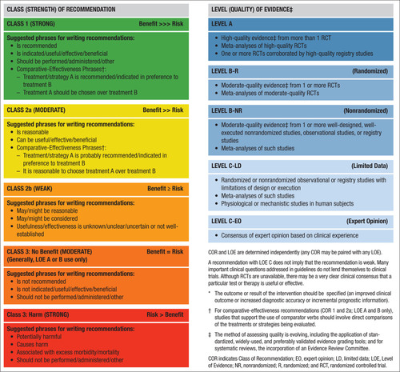

**Table 2. Applying American College of Cardiology/American Heart Association Class of Recommendation and Level of Evidence to Clinical Strategies, Interventions, Treatments, or Diagnostic Testing in Patient Care\* (Updated May 2019)**